Accessing Canvas
All faculty who teach at Salt Lake Community College are now required to use Canvas for gradebook, assignments, homepage, and syllabus. If you teach here at SLCC, then you may be wondering how do you get to Canvas? It’s actually very easy. Follow the steps below to access Canvas.
Steps:
- Open a browser window. Note: Google Chrome works best with Canvas.
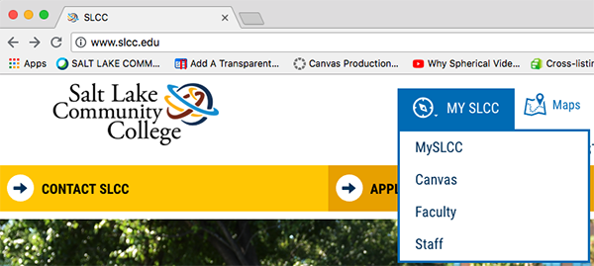
- Type slcc.edu in the address bar and press Enter/Return on your keyboard.
- On the SLCC homepage, hover over MY SLCC. You should see a menu drop down. Click on Canvas. (Figure 1
Figure 1
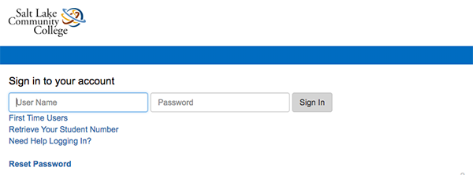
- Sign in using your My SLCC username and password. (Figure 2)
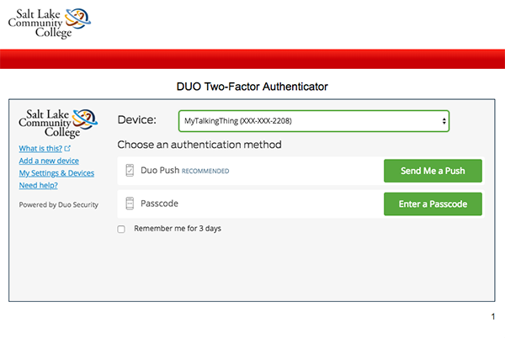
- Enter the code from your Duo account to authenticate your login. If you have not set up your Duo account, you will need to do this first before trying to log into Canvas. (Figure 3)
Figure 2
- After you have successfully entered your code, you will be taken to the main dashboard of Canvas.
From here, you will be able to access your course for grading, student communication, or to setup your homepage.
Figure 3
If you need help with Canvas, you can call 801-957-5125 and select Option 2 which will connect you to Canvas Support. If you need help with your course, you can setup an appointment with an Instructional Technologist by emailing at eLearningSupport@slcc.edu. Our Instructional Technologists will be happy to help you.

